Summer Reading Assignment

Over the summer months, students are required to select one book option to read from our grade level summer reading list. For the selected book that he/she reads, the student must complete one writing assignment and one project from the choices below. The assignments (both writing and project) will be due Tuesday, September 5th.

Choose One Writing Assignment:

- Book Review: Write a two-page (5 paragraphs) review of your book. (See attached organizer.)

- Journal: Create a journal in the voice of a character from your book. Write at least 10 journal entries, a minimum of three pages. (See attached organizer.)

Choose One Project Assignment

- Timeline: Create a timeline of at least 15 events in your book. Include an illustration and a caption for each major event.

- Book Jacket: Create a book jacket that provides a front and back cover; the design should include the book title, author’s name, imagery reflecting the theme of the book, a story summary and a book review. (See attached organizer)

- Travel Brochure: Create a three-fold brochure for people traveling to the place and time of your book. Introduce the culture and describe any differences in lifestyles and beliefs that travelers from your place and time should know about. (See attached organizer)

- Comic Strip: Create a comic strip with captions that takes us through the plot development of the story. The illustrations should follow the correct order of the story, highlighting key events. (See attached organizer and template)
Book Review Organizer

Opening Sentence: First, write a complete sentence capturing your reader’s attention.

TAG (Title, Author, Genre): Then, write a complete sentence telling your reader the title, author, and genre of your book.

Summary (8+ sentences): Now, write about two paragraphs summarizing the book in your own words. This should NOT look just like the back of the book, but should include details from the story. Also, remember that this part of the review should not include any opinion.

Additional Information (4 sentences): In another paragraph, write three to four sentences giving additional information about the book or author to help readers better understand. Choose one:
- Favorite quotation: Introduce the quote in your own words so that the reader can understand what is happening at that point in the story. Use quotation marks! Then, explain why this is your favorite quotation.
- Favorite character: Describe your favorite character and explain why he/she is your favorite.
- Author’s purpose: Explain why you think the author wrote this book. Did he/she want to inform, to persuade, to entertain, or to teach the reader?
- About the Author: Provide additional information about the author. This could include a link to his/her website and biographical information.

Recommendation (2 sentences): Finally, write three sentences telling others if you would recommend this book. Explain why or why not. Also, try to think of the type of person who would like this book, even if you did not (for example, “I recommend this book to anyone interested in time travel.”).

Book Review Rubric

Book Review opens with a complete sentence that captures the reader’s attention. | ______ / 5
TAG (Title, Author, Genre) | ______ / 5
Summary is at least 8 sentences in length (about two paragraphs). Summary is in the student’s words and provides specific details from the book. | ______ / 20
At least three sentences providing additional information from one of the following categories:  - Favorite Quotation  - Favorite Character  - Author’s Purpose  - About the Author | ______ / 15
At least two sentences recommending the book. | ______ / 5

______ / 50

Journal Guidelines

Completed journal entries should add up to at least three pages; you may skip a line between entries. There should be at least 10 entries. If your entries are short, you will have to write more to fill the page requirement. Don’t forget to date each entry!

Try to express the point of view of the character you choose. Reflect on actual events that occur in the story. Think about how he or she felt during each scene/chapter you choose to write an entry for. This could also mean using vocabulary that is from a different decade (for example, if your book is set in the 1800s, the character would sound very different than one from present-day)!

Journal Rubric

Journal entries express the point of view of the chosen character. His/her emotions during each scene are clear. | ______ / 10
Entries are dated and reflect on actual events that occur in the book | ______ / 10
Journal is at least three pages in length, with no more than one line skipped between entries. There are at least 10 entries total. | ______ / 20
Vocabulary used in the entries matches the time period of the book and/or the type of character chosen. | ______ / 10

______ / 50

Timeline Rubric

At least 15 events are represented. Events cover the entirety of the book, not just the beginning. | ______ / 15
Student has illustrated a picture or symbol for each event. | ______ / 15
Student had provided a caption to explain each illustration. | ______ / 15
Timeline is neat and easy to read. | ______ / 5

______ / 50

Book Jacket Template/Organizer
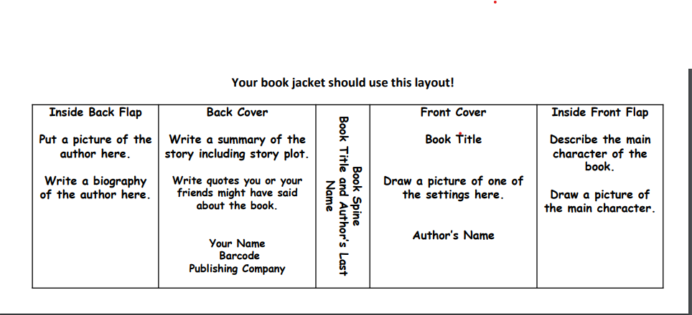
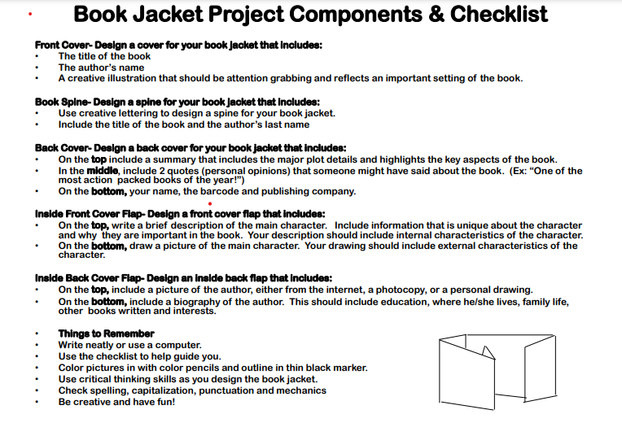

Book Jacket Rubric

Content Standards:  *All components are present  *All components are supported by comprehensive and accurate content  *Information represents an in depth, insightful and advnaced understanding of the content standard topics | ______ / 10
Conventions & Layout:  *There are no errors (spelling, punctuation, capitalization, sentence structure) present in the writing.  *Directions were clearly followed, and all components are in the correct spots. | ______ / 30
Creativity & Attractiveness:  *The project is remarkably creative and unique in terms of design.  *The project is exceptionally attractive in terms of layout and neatness. | ______ / 10

______ / 50

Travel Brochure Rubric

The brochure contains six panels with information or illustrations. | ______ / 10
The brochure focuses on explaining the time, place, and culture of the book’s setting. After reading this brochure, someone would be able to understand the world the characters live in. | ______ / 30
Brochure is colorful, neat, and contains little/no “white space.” | ______ / 10

______ / 50

COMIC STRIP ORGANIZER

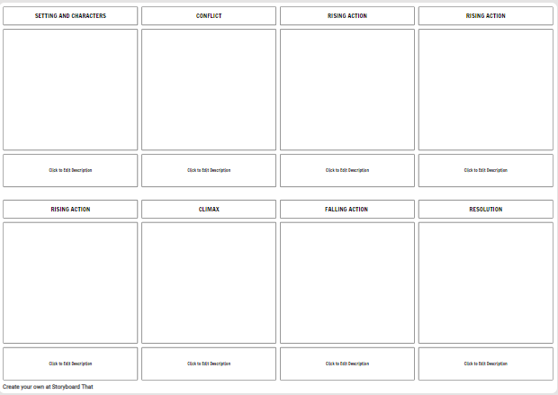

COMIC STRIP Rubric

The comic strip contains eight panels with illustrations and captions. | ______ / 10
Creativity and accuracy are reflected highlighting the key events of the story including; setting and character, conflict, rising actions, climax, falling action and resolution. | ______ / 30
Brochure is colorful, neat, and contains little/no “white space.” | ______ / 10

______ / 50

